## University of the People

## Writing Assignment Unit 3

## CS 2401 - Software Engineering 1

## February 15, 2023

Q: You are hired to develop a software system for motion detection and garage door control. The system should turn the garage door lights on automatically when it detects motion within a given perimeter. The garage door opener should be possible to control either by a remote radio transmitter or by a manual button switch. The opener should include the following safety feature. An “electric eye” sensor, which projects invisible infrared light beams, should be used to detect if someone or something passes under the garage door while it closes. If the beam is obstructed while the door is going down, the door should not close—the system should automatically stop and reverse the door movement.

* motion detector
* external light bulb
* motor for moving the garage door
* “electric eye” sensor
* remote control radio transmitter and receiver
* manual opener button switch

Assume that all the hardware components are available and you only need to develop a software system that controls the hardware components.

1. The actors for the system and their goals

Actor: **Resident / user**

Purpose: to control the garage door by a remote radio transmitter or by a manual button switch

Actor: **Motion detector**

Purpose: to open the garage door’s light automatically when motion is detected within a given perimeter

Actor: **“electric eye” sensor**

Purpose: to project invisible infrared light beams to detect if someone or something is passing through under the garage door while it is closing and to reverse the motion

Actor: **Timer**

Purpose: to close the garage door after a period of time, and to turn on and off the light of the garage door at the scheduled time

1. the use cases relevant to the system objective and text description of each

Open Remotely: To open the garage door once the open switch is pressed on the remote radio transmitter.

Close Remotely: To close the garage door once the close switch is pressed on the remote radio transmitter.

Open Manually: To open the garage door once the manual button switch is pressed.

Close Manually: To close the garage door once the manual button switch is pressed.

Auto Light On: To turn on the light when motion is detected or when the door starts to open.

Auto Light Off: To turn off the light after a set amount of time once the motion is detected or the door is closed.

Auto Reverse: The door will automatically reverse the closing procedure and open the door when someone or something is detected to be passing through under the garage door while it is closing.

1. the use case diagram for the system

According to Marsic (2012), the use case diagram for the system is given as follows.

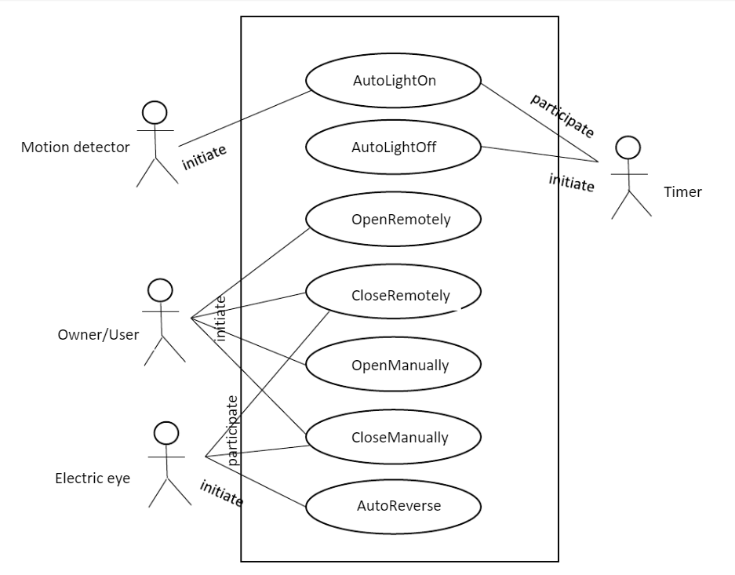

1. a fully dressed description for the use case that deals with the remote-controlled garage door opening,

When the user is detected within the given range, the light will turn on. And once the user presses the open switch from the remote controller, the system will verify the received command. Then once the command is successfully verified, the motor to open the door will start unwinding and the garage door will start opening. And the user will be able to enter the garage.

An alternative scenario could be when the system receives invalid command or the wrong code from the user, the system will alert the user immediately.

1. the system sequence diagram(s) for the use case selected in (d)

According to Marsic (2012), the system sequence diagram for the use case is given as follows.

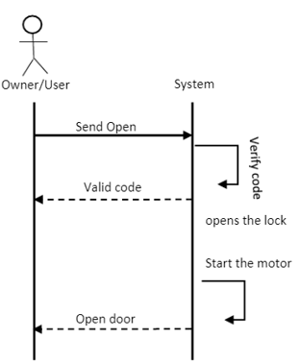

1. the operation contracts for the operations of the use case selected in (d)

Operation Unit: Open the garage door remotely.

Procedure: To open the garage door once the user presses the open switch from remote radio transmitter.

Pre-conditions: To open the light automatically once the motion is detected.

Post-conditions: To close the light automatically after a period of time, once the garage door is closed.

**References**

Marsic, I. (2012). *Software engineering.* Rutgers Unversity. [**http://www.ece.rutgers.edu/~marsic/books/SE/book-SE_marsic.pdf**](http://www.ece.rutgers.edu/~marsic/books/SE/book-SE_marsic.pdf).